**Around 1047 – 930 BC**

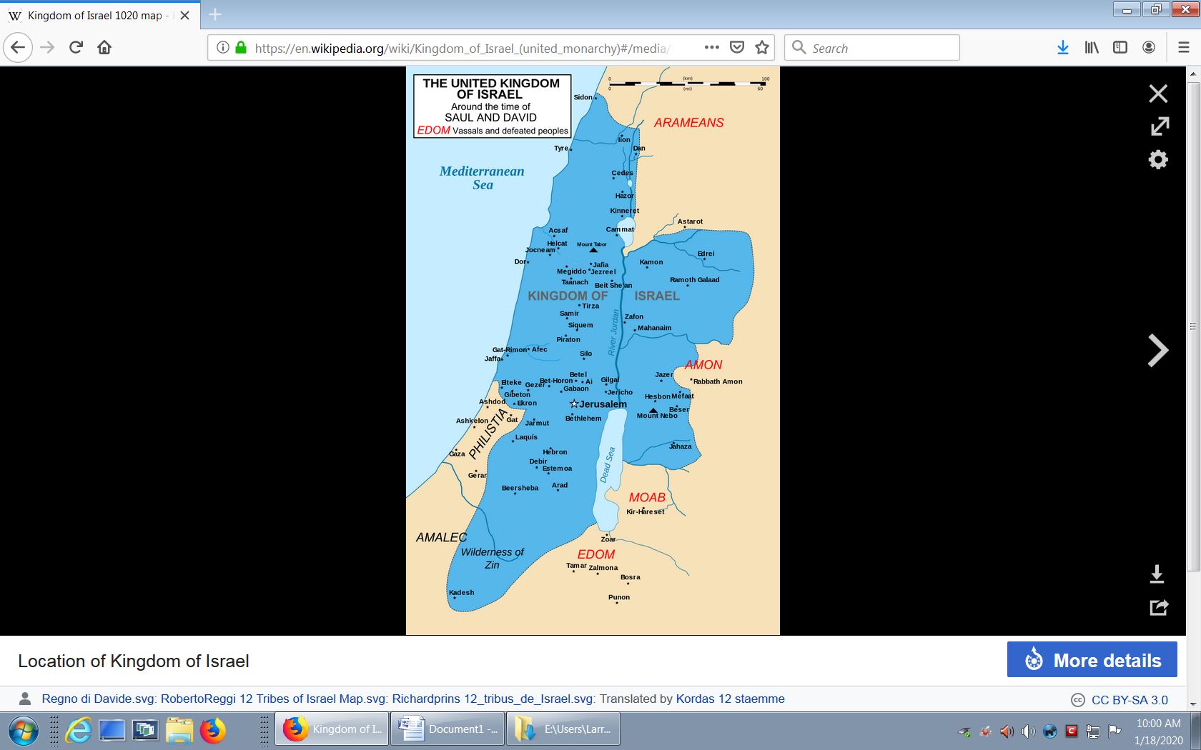

**Kings:**

1047 – 1010 BC **Saul**

1010 – 1008 BC Ishbaal

1008 - 970 BC **David**

970 - 931 BC **Solomon**

931 - 930 BC Rehoboam

**Kingdoms of Israel after death of King Solomon. Northern Kingdom did not want King Solomon’s son Rehoboam to rule over them.**

